# HOSPICE CONNECT



BY

Sai Sandeep Mutyala (17BD1A0516)

Preeti Glenorine Dcruze (17BD1A051C)

Prerna Patra (17BD1A051D)

Shreya Gandhe (17BD1A051H)

Yaganti Shreya (17BD1A051V)

A PROJECT REPORT

SOFTWARE ENGINEERING LABORATORY

FOR B.TECH. IN COMPUTER SCIENCE AND ENGINEERING

DEPARTMENT OF COMPUTER SCIENCE AND ENGINEERING

KESHAV MEMORIAL INSTITUTE OF TECHNOLOGY

NARAYANGUDA, HYDERABAD, 5000029

(AFFILIATED TO JNTUH)

NOVEMBER 2019

Table of Contents

1. INTRODUCTION 1
   1. Purpose 1
   2. Scope 1
   3. Overview 1
   4. Process Model - Scrum 2
2. REQUIREMENTS SPECIFICATION 3
   1. High-Level Functional Requirements 3
      1. KYH01: Looking for nearby hospitals 3
      2. KYH02: Emergency Service Provider 3
      3. KYH03: Book an appointment 3
      4. KYH04: Rate hospitals and doctors 3
      5. KYH02: Online Consultancy 3
   2. Requirements Specification 3
      1. Use Case Diagrams 4
         1. Hospice Connect Use Case diagram 4
         2. UC161 Search Use Case diagram 5
         3. UC1C2 Emergency Use Case diagram 5
         4. UC1D3 Appointment Use Case diagram 6
         5. UC1H4 Rating Use Case diagram 6
         6. UC1V5 Online Consultancy Use Case diagram 7
      2. Use Case Specification 7
         1. UC161 Search Use Case 7
         2. UC1C2 Emergency Use Case 8
         3. UC1D3 Appointment Use Case 9
         4. UC1H4 Rating Use Case diagram 9
         5. UC1V5 Online Consultancy Use Case diagram 10
   3. Non-Functional Specification 11
3. PRELIMINARY DESIGN 12
   1. Class Diagrams 12
      1. Hospice Connect Class Diagram 12
      2. CD516 Search Class Diagram 13
      3. CD51C Emergency Class Diagram 13
      4. CD51D Appointment Class Diagram 14
      5. CD51H Rating Class Diagram 15
      6. CD51V Online Consultancy Class Diagram 16
4. DETAILED DESIGN 17
   1. GUI Design 17
      1. Search GUI Design 17
      2. Emergency GUI Design 18
      3. Appointment GUI Design 19
      4. Rating GUI Design 19
      5. Online Consultancy GUI Design 20
5. IMPLEMENTATION AND TESTING 21
   1. Test Case Design 21
      1. Search Test Case Design 21
      2. Emergency Test Case Design 22
      3. Appointment Test Case Design 23
      4. Rating Test Case Design 23
      5. Online Consultancy Test Case Design 24
   2. Implementation 26
6. CONCLUSION AND FUTURE WORK 30

Appendix A. Requirement Traceability 30

Appendix B. Design Traceability 31

Appendix C. Data Dictionary 32

Appendix D. Test Log 33

**Table of Figures**

Figure 1.4 Scrum Model 2

Figure 2.2.1.1 Hospice Connect Use Case 4

Figure 2.2.1.2 Search Use case 5

Figure 2.2.1.3 Emergency Use case 5

Figure 2.2.1.4 Appointment Use case 6

Figure 2.2.1.5 Rating Use Case 6

Figure 2.2.1.6 Online Consultancy Use Case 7

Figure 3.1.1 Hospice Connect Class Diagram 12

Figure 3.1.2 Search Class Diagram 13

Figure 3.1.3 Emergency Class Diagram 13

Figure 3.1.4 Appointment Class Diagram 14

Figure 3.1.5 Rating Class Diagram 15

Figure 3.1. 6 Online Class Diagram 16

Figure 4.1.1 Hospice Connect GUI Design 17

Figure 4.1.2 Search GUI Design 18

Figure 4.1.3 Emergency GUI Design 18

Figure 4.1.4 Appointment GUI Design 19

Figure 4.1.5 Rating GUI Design 20

Figure 4.1.6 Online Consultancy GUI Design 20

Figure 5.2.1 Hospice Connect Implementation 26

Figure 5.2.2 Search Implementation 27

Figure 5.2.3 Emergency Implementation 28

Figure 5.2.4 Appointment Implementation 28

Figure 5.2.5 Appointment Implementation 29

Figure 5.2.6 Rating Implementation 29

Figure 5.2.7 Online Consultancy Implementation 30

**List of Tables**

Table 2.2.3.1: Search Use Case 7

Table 2.2.3.2**:** Emergency Use Case 8

Table 2.2.3.3: Appointment Use Case 9

Table 2.2.3.4: Rating Use Case 9

Table 2.2.3.5: Online Consultancy Use Case 10

Table 3.1.1 Search Class Diagram 13

Table 3.1.2 Emergency Class Diagram 14

Table 3.1.3 Appointment Class Diagram 14

Table 3.1.4 Rating Class Diagram 15

Table 3.1.5 Online Class Diagram 16

Table 5.1. 1 Search Test Case Design 21

Table 5.1.2 Emergency Test Case Design 22

Table 5.1.3 Appointment Test Case Design 23

Table 5.1.4 Rating Test Case Design 24

Table 5.1.5 Online Consultancy Test Case Design 25

Table 6.1: Requirements Traceability Matrix 31

Table 6.2: Design Traceability Matrix 32

Table 6.1.1 Search Test Log 34

Table 6.1.2 Emergency Test Log 35

Table 6.1.3 Appointment Test Log 36

Table 6.1.4 Rating Test Log 37

Table 6.1.5 Online Consultancy Test Log 38

## 1. INTRODUCTION

### Purpose

The purpose of this project is to implement software for an application that provides consolidated information about doctors and hospitals (government and private) so the citizens should be able to choose a hospital and doctors that best suits their needs. A user is able to access the services provided by the app using a valid username and password. The following services will be offered to the user by this system:

* + - Look for nearby private or government hospitals (Limit of search radius fixed to one mile).
    - Contact any emergency service provider, both private and government.
    - Locate the doctors for a particular illness or field and make an appointment.
    - Rate the doctor and hospital.
    - Online consultancy with the top doctors in any field.

### Scope

This project will only implement the software necessary to implement the services for the user. The hospital server is assumed to be already implemented and this system will interface with the hospital server to achieve its objectives. Only the user interface prototypes of the systems will be implemented in this project to understand the requirements. Prototypes will be thrown away when the actual system is implemented.

### Overview

Section 2. lists all the high-level functional requirements of the system. These requirements were elicited from the description provided for the projects and discussions with the customer/instructor of this course. Section 3. provides the preliminary design in terms of identifying the classes using Object-Oriented Analysis and Design approach. Class Responsibility and Collaboration (CRC) technique was used for this purpose and class diagrams. Section 4. provides the activity diagrams and GUI prototype designs and activity diagrams for work flow analysis. Section 5. provides test case design tables along with implementation details and any screen shots of the actual user interface prototype implementation of the system. Section 6. will contain the conclusions and future work of the project.

### Process Model – SCRUM

Scrum is a framework within which people can address complex adaptive problems, while productively and creatively delivering products of the highest possible value. Scrum itself is a simple framework for effective team collaboration on complex products.

The Scrum Values include Courage, Focus, Commitment, Respect, and Openness.

The Scrum Team consists of a [Product Owner](https://www.scrum.org/resources/what-is-a-product-owner), the [Development Team](https://www.scrum.org/resources/what-is-a-scrum-development-team), and a [Scrum Master](https://www.scrum.org/resources/what-is-a-scrum-master). Scrum Teams are self-organizing and cross-functional. Self-organizing teams choose how best to accomplish their work, rather than being directed by others outside the team. Cross-functional teams have all competencies needed to accomplish the work without depending on others not part of the team. The team model in Scrum is designed to optimize flexibility, creativity, and productivity.

Scrum Process Model

Figure 1.4 Scrum Model

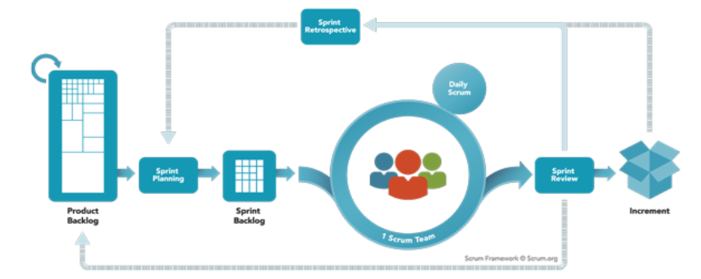

## REQUIREMENT SPECIFICATION

### High-level Functional Requirements

The function requirements of the system specify the behavior of the system. The requirements are elicited from the description of the project and in consultation with the customer/instructor of this project/course.

### KYH01: Looking for nearby hospitals

Citizens are able to find the nearest government or private hospitals in case of an emergency.

### KYH02: Emergency Service Provider

### The app displays a list of all the ambulance service providers' numbers, along with other emergency contacts. The app has buttons, which when clicked places a call to the selected service provider.

### KYH03: Book an appointment

### Citizens are able to locate the doctors for a particular illness or field and make an appointment.

### KYH04: Rate hospitals and doctors

### Citizens are allowed to rate hospitals and doctors.

### KYH05: Online Consultancy

### Customers can select their doctors from desired fields and chat with them regarding their problems through a chat-box.

### Requirements Specification

Here scenario-based approach called use cases were established. Use cases correspond to the specification of the requirements based on the interactions of the user with the system to achieve a functional requirement. Use case diagrams were drawn using ArgoUML and StarUML.

### Use Case Diagrams

Use case diagrams are behavioral diagrams that have actors, use cases and relationships among the use cases. The rectangular box represents the context of the system. All use cases within the box are implemented by the system.

### Hospice Connect Use Case diagram

Figure 2.2.1.1 shows the detailed description of Hospice Connect Use Case diagram

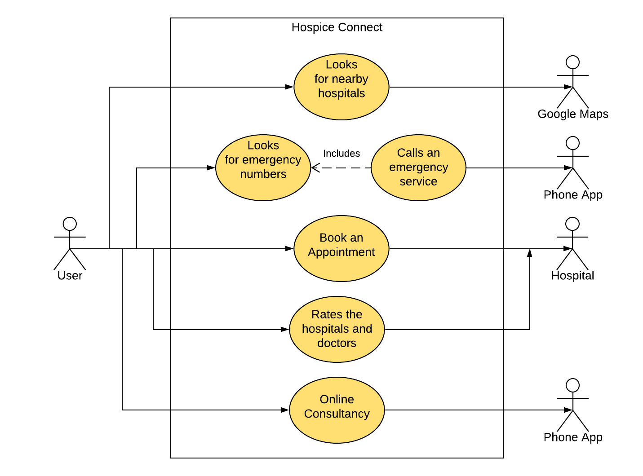

Figure 2.2.1.1 Hospice Connect Use Case

The user can start a session. That includes many functions like looking for hospitals, booking an appointment, rating the doctors and hospital, consult a doctor online using the online consultancy and contact both private and government emergency service providers. The user is redirected to Google Maps, The Phone app and the Hospital server for each of the selected function. The Hospital can in-turn access the app for details regarding the appointments and ratings

### UC161 Search Use Case diagram

Figure 2.2.1.2 shows the detailed description of Search Use Case.

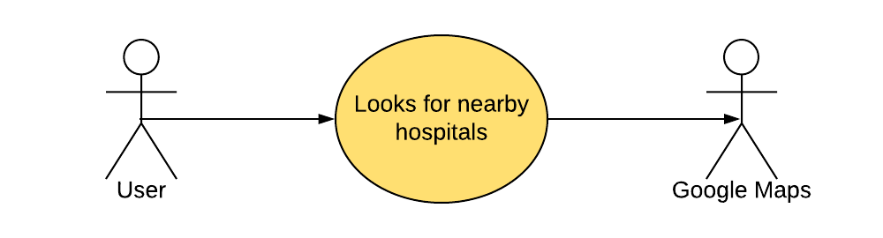

Figure 2.2.1.2 Search Use case

Nearby hospitals are displayed on the map.

### UC1C2 Emergency Use case diagram

Figure 2.2.1.3 shows the detailed description of Emergency Use Case.

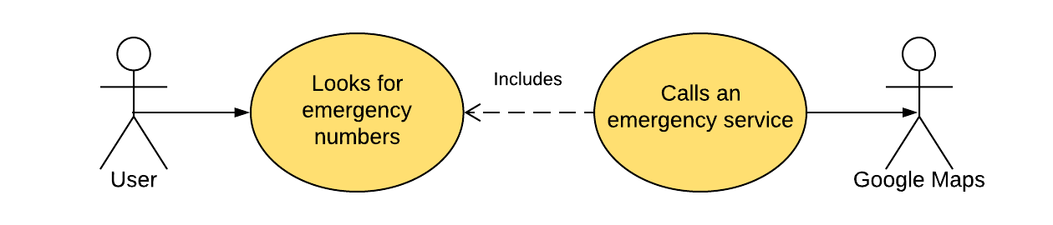

Figure 2.2.1.3 Emergency Use case

The user is able to call any one of the ambulance or emergency service provider directly through the app. On selecting a particular service provider, the user is directed to the phone app on his/her device using which they can place a call to the service provider.

### UC1D3 Appointment Use case diagram

Figure 2.2.1.4 shows the detailed description of Appointment Use Case.

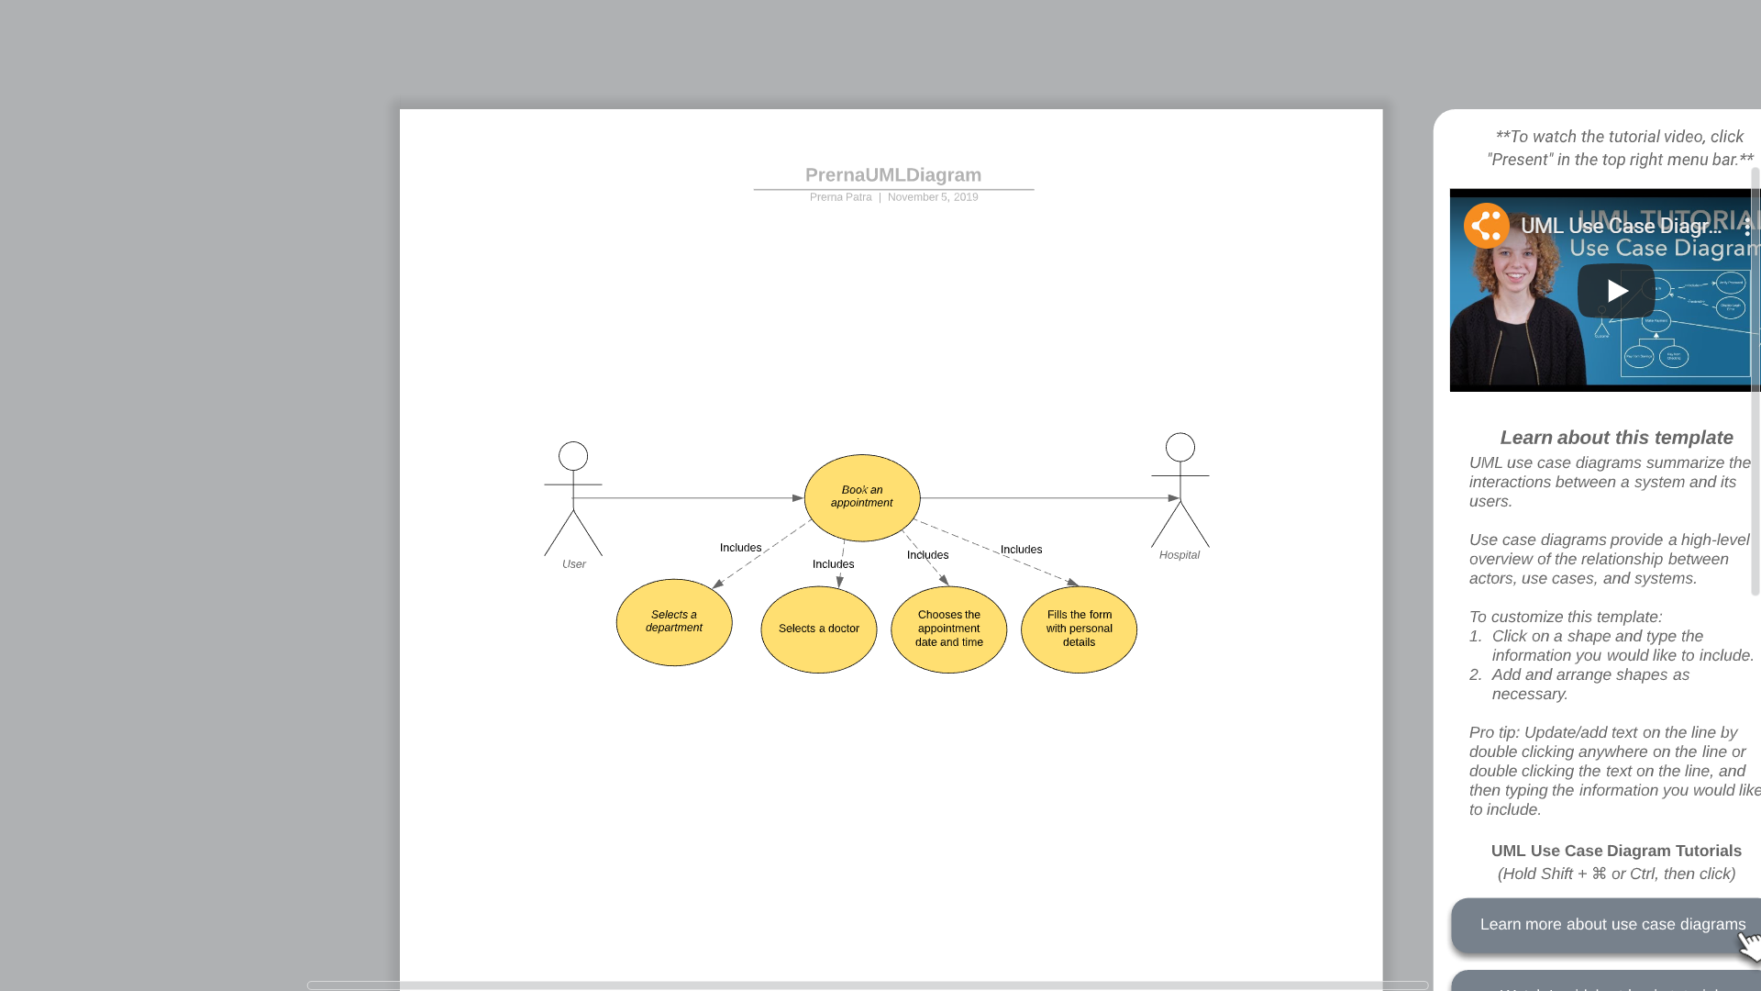

Figure 2.2.1.4 Appointment Use case

### The user firstly has to select which department of the hospital they require assistance from. This step is followed by selecting a doctor of that department and the date and time slot of the appointment. Finally, the user has to fill the form with personal details. This completes the process of booking an appointment.

### UC1H4 Rating Use case diagram

Figure 2.2.1.5 shows the detailed description of Rating Use Case.

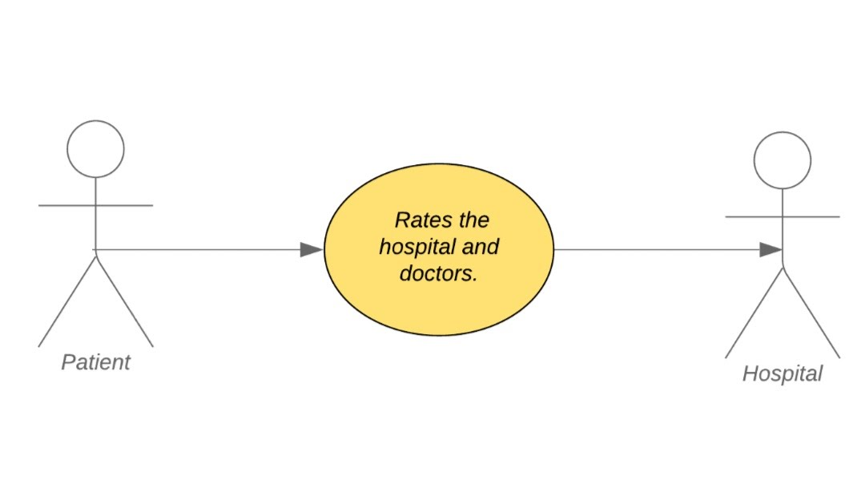

Figure 2.2.1.5 Rating Use Case

After using the services of the app, the patient/user gets to rate the hospital. On clicking the rate us button, a questionnaire is displayed. The user can rate the hospital and doctors in accordance to the questions. After this task is completed a comment box pops up where the user can write his/her reviews.

### UC1V5 Online Consultancy Use case diagram

Figure 2.2.1.6 shows the detailed description of Online Consultancy use case.

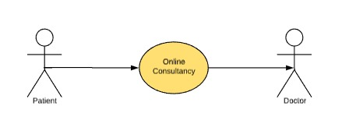

Figure 2.2.1.6 Online Consultancy Use Case

The User clicks on the online consultancy button and then a list appears where he/she has to select his /her problem. Then the list of doctors will be displayed with their ratings, online status and other details. When the user selects the doctor a chat box opens up where the user can talk with the doctor after the chat is done, he/she should rate the doctor. The patient can talk to the doctor without going to a hospital.

### Use Case Specification

Each use case is specified in detail to document each use case diagram in text. The following shows tables show the documentation for each use case in the previous section.

### : UC161 Search Use Case

### Table 2.2.3.1 shows the documentation for the use case specified in figure 2.2.1.2.

Table 2.2.3.1: Search Use Case

|  |  |  |  |  |
| --- | --- | --- | --- | --- |
| **Use Case ID:** | UC161 | | | |
| **Use Case Name:** | Search for nearest hospitals | | | |
| **End Objective:** | User should be able to search for the nearby hospitals, and view their details. | |  |  |
| **Created by:** | Sai Sandeep Mutyala | | **On (date):** | 18 August 2019 |
| **User/Actor:** | User | | | |
| **Trigger:** | User presses a button to search for the nearest hospitals. Clicking a marker should display its details. | | | |
| Basic Flow | | | | | |
| **User Actions** | | **System Actions** | | | |
| - User clicks a button. - Clicks a marker. | | - Nearest hospitals are marked on the map. - Displays details of a marker. | | | |
| Exception Flow | | | | | |
| **User Actions** | | **System Actions** | | | |
| - User clicks a button. | | - If no hospitals are found, display a message saying so. | | | |

### : UC1C2 Emergency Use Case

### Table 2.2.3.2 shows the documentation for the use case specified in figure 2.2.1.3.

Table 2.2.3.2**:** Emergency Use Case

|  |  |  |  |
| --- | --- | --- | --- |
| **Use Case ID:** | UC1C2 | | |
| **Use Case Name:** | List of ambulance numbers | | |
| **End Objective:** | Contact an ambulance service for an ambulance |  |  |
| **Created by:** | Preeti Glenorine Dcruze | **On (date):** | 18 August 2019 |
| **User/Actor:** | User | | |
| **Trigger:** | User clicks on a button to display the list. To contact the respective service, the user is required to click on the call icon to place the call. | | |
| Basic Flow | | | |
| **User Actions** | | **System Actions** | |
| **-**User opens the app  **-**User selects the 'List of Ambulance Services' option  **-**User chooses the ambulance service provider and clicks on the call icon adjacent to the service name  **-**User places a call by clicking on the call button  **-**After the user is done, he presses the 'End Call' button | | **-**A list of services provided by the app is displayed  **-**A table with all the emergency contacts are displayed  **-**The Dialpad with the service's number is displayed  **-**The call is placed by establishing a connection with the service  **-**Connection with the service is ended and the 'List of Ambulance Services'  page is displayed | |
| Exception Flow | | | |
| **User Actions** | | **System Actions** | |
| **-**User selects the wrong service number | | **-**Connection is not established.The service line is busy | |

### : UC1D3 Appointment Use case

### Table 2.2.3.3 shows the documentation for the use case specified in figure 2.2.1.4.

Table 2.2.3.3: Appointment Use Case

|  |  |  |  |
| --- | --- | --- | --- |
| **Use Case ID:** | UC1D3 | | |
| **Use Case Name:** | Locate the doctor and make an appointment | | |
| **End Objective:** | An appointment is made |  |  |
| **Created by:** | Prerna Patra | **On (date):** | 18 August 2019 |
| **User/Actor:** | Patient | | |
| **Trigger:** | Click on the "Place an appointment" button. | | |
| Basic Flow | | | |
| **User Actions** | | **System Actions** | |
| 1. The desired hospital is chosen.    2. If the user doesn't know which doctor to consult.  User enters the symptoms or about the illness. 3. The user clicks on the 'Place an appointment' option after selecting the doctor and enters his/her personal information. 4. Clicks on the 'Submit' button. | | 1. The list of doctors according to their designation available in the particular hospital is displayed. 2. List of doctors for that particular illness or field is displayed. 3. The details are stored in the database.  4. The appointment is set and a confirmation mail is sent to their email id. | |
| Exception Flow | | | |
| **User Actions** | | **System Actions** | |
| 1. User selects the wrong doctor.  2. User enters the wrong email id. | | 1. The illness cannot be treated. The user has to consult the correct doctor some other time. 2. Confirmation mail is not received. | |

### : UC1H4 Rating Use case

### Table 2.2.3.4 shows the documentation for the use case specified in figure 2.2.1.5.

Table 2.2.3.4: Rating Use Case

|  |  |  |  |  |
| --- | --- | --- | --- | --- |
| **Use Case ID:** | UC1H4 | | | |
| **Use Case Name:** | Allow citizens to rate hospitals and doctors. | | | |
| **End Objective:** | Rating is stored in the database. | |  |  |
| **Created by:** | Shreya Gandhe | | **On (date):** | 18 August 2019 |
| **User/Actor:** | Citizens | | | |
| **Trigger:** | User clicks the rating button to rate the hospitals and doctors. | | | |
| Basic Flow | | | | | |
| **User Actions** | | **System Actions** | | | |
| 1.User clicks the rating button. 2. The user selects a rating level. 3. User fills the suggestion box with the areas that require improvement. | | 1.The rating scale is displayed. 2. The rating level is stored in the database. If the rating is low, a suggestion box pops up. 3. The data is stored. | | | |
| Exception Flow | | | | | |
| **User Actions** | | **System Actions** | | | |
| 1.User doesn't select a rating level. | | 1.Error message is displayed asking them to fill the rating level. | | | |

### : UC1V5 Online Consultancy Use case

### Table 2.2.3.5 shows the documentation for the use case specified in figure 2.2.1.6.

Table 2.2.3.5: Online Consultancy Use Case

|  |  |  |  |
| --- | --- | --- | --- |
| **Use Case ID:** | UC1V5 | | |
| **Use Case Name:** | <Name – concise results oriented-name with an action verb and a noun. > | | |
| **End Objective:** | User should be able to chat with the doctor about his problem |  |  |
| **Created by:** | **Yaganti Shreya** | **On (date):** | 18 August 2019 |
| **User/Actor:** | Customers and Doctors | | |
| **Trigger:** | User should click on the chat option displayed and select a doctor according to his health issue | | |
| Basic Flow | | | |
| **User Actions** | | **System Actions** | |
| 1. User selects the chat option.  2. User selects the disease.  3. User selects a doctor. | | 1. A list of diseases or health problems will be displayed. 2.List of doctors with their qualification, rating, and online status will be displayed.  3. A chat box opens up. | |
| Exception Flow | | | |
| **User Actions** | | **System Actions** | |
| 1. Use selects a doctor who is not online | | 2. Shows a message that the doctor is not online, choose an alternative. | |

### 2.3 Nonfunctional Requirements

The **non**-**functional requirements** (NFRs) define attributes such as availability, maintainability, performance, reliability, scalability, security, and usability. They serve as constraints on the design of the solution and state which qualities are needed or valuable.

The non-functional requirements of this software application are:

1. Search for hospitals must be performed within a radius.
2. Ensure that the database has updated numbers.
3. If the provider can be reached using more than one number, the other numbers should be included as well.
4. The database of doctors should be categorized according to the diseases or illness they can treat.
5. Details must be entered carefully while making an appointment. The details should be valid.
6. The rating should be anonymous.
7. A scale should be provided so that the citizens can rate accordingly.
8. If the rating is poor then the citizens will be asked a series of questions regarding areas of improvement.
9. There will be a time limit for the consultation period
10. Doctors qualification will be displayed beforehand
11. Patients privacy is intact
12. In case of misbehavior report option will be provided

**3.0 PRELIMINARY DESIGN**

The preliminary design is a key step in the early stages of software development, where customer requirements and use cases support the creation of the system architecture. User Interface documents, screen navigation flow, entity relationship diagrams, and system architecture documents are some of the items that should be included in the design. With these inputs, the preliminary design will present the visual representation of the system at project outset.

The preliminary design review (PDR) is a project-level review with stakeholders and [project management](https://www.sciencedirect.com/topics/computer-science/project-management) representatives to review the software [functional architecture](https://www.sciencedirect.com/topics/computer-science/functional-architecture), and gather feedback on the [functional definitions](https://www.sciencedirect.com/topics/computer-science/functional-definition), performance allocations, behaviors, data definitions, [functional specifications](https://www.sciencedirect.com/topics/computer-science/functional-specification), and plans for the next development stage.

**3.1 Class Diagrams**

In software engineering, a class diagram in the Unified Modeling Language is a type of static structure diagram that describes the structure of a system by showing the system's classes, their attributes, operations, and the relationships among objects.

**3.1.1 Hospice Connect Class Diagram**

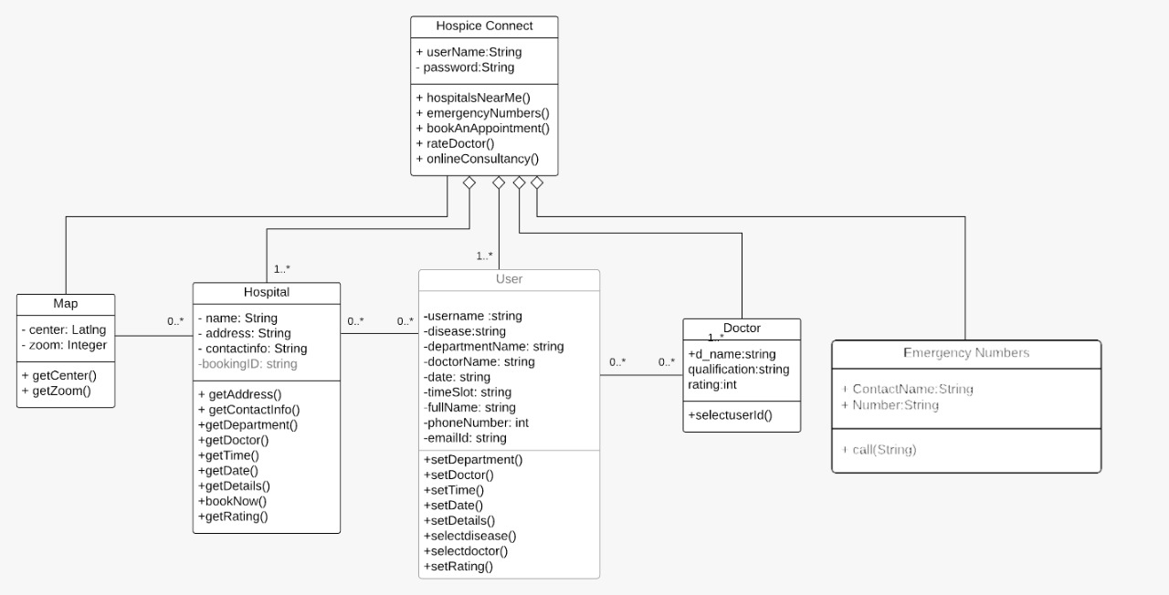

Figure 3.1.1 Hospice Connect Class Diagram

**3.1.2 CD516 Search Class Diagram**

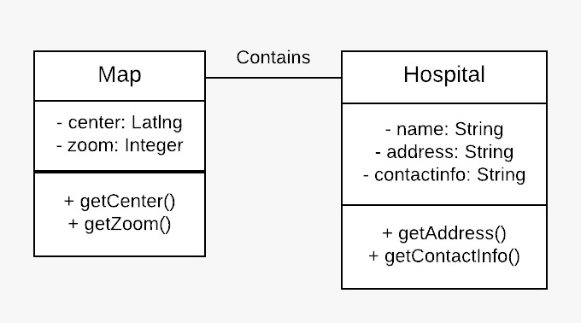

Figure 3.1.2 Search Class Diagram

Table 3.1.1 Search Class Diagram

|  |  |
| --- | --- |
| **Name** | Map, Hospital |
| **Attributes** | center: center of the map zoom: zoom of the map name: name of the hospital address: address of the hospital contactinfo: contact information of the hospital |
| **Methods** | getCenter(): returns the center coordinates of the map getZoom(): returns the zoom of the map getAddress(): returns the address of the hospital getContactInfo(): returns the contact info of the hospital |
| **Relationship** | A map contains many hospitals. |

**3.1.3 CD51C Emergency Class Diagram**

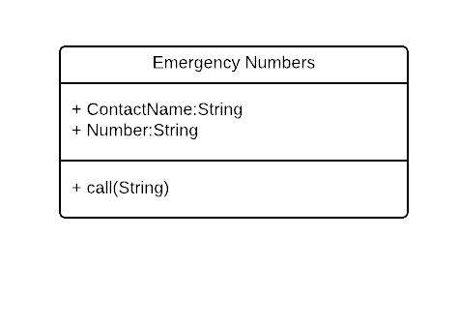

Figure 3.1.3 Emergency Class Diagram

Table 3.1.2 Emergency Class Diagram

|  |  |
| --- | --- |
| **Name** | Emergency List |
| **Attributes** | contactName : Name of the Emergency Service Provider Number : Number of the Emergency Service Provider |
| **Methods** | call(String) : calls the selected service provider whose number is mentioned as a parameter |
| **Relationship** | Can be used to look for and call an ambulance to a particular hospital |

**3.1.4 CD51D Appointment Class Diagram**

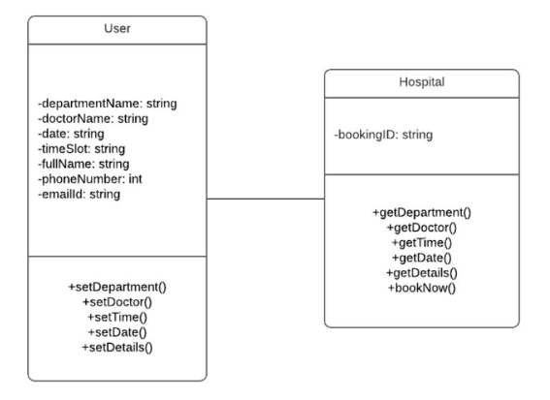

Figure 3.1.4 Appointment Class Diagram

Table 3.1.3 Appointment Class Diagram

|  |  |
| --- | --- |
| **Name** | User, Hospital |
| **Attributes** | departmentName: Name of the Departments  doctorName: Name of the Doctor date: Date to book an appointment timeSlot:  Time to book an appointment fullName: Name of the user phoneNumber: Contact information about the user emailId : Email ID of the user bookingID: Displays the booking id after the appointment is made |
| **Methods** | **Setting** setDepartment(): User selects department  setDoctor(): Select a Doctor setTime(): Select a time setDate(): Select a date setDetails(): Give personal details like Name, Phone number and email id  **Getting** getDepartment(): Used to get the selected department getDoctor(): Get the selected Doctor getTime(): Get the selected time getDate(): Get e selected date getDetails(): To get personal details like Name, Phone number and email id  **Booking** bookNow(): To place an appointment by gathering the above details and display the booking id on the screen |
| **Relationship** | The user can give in required details and book an appointment |

**3.1.5 CD51H Rating Class Diagram**

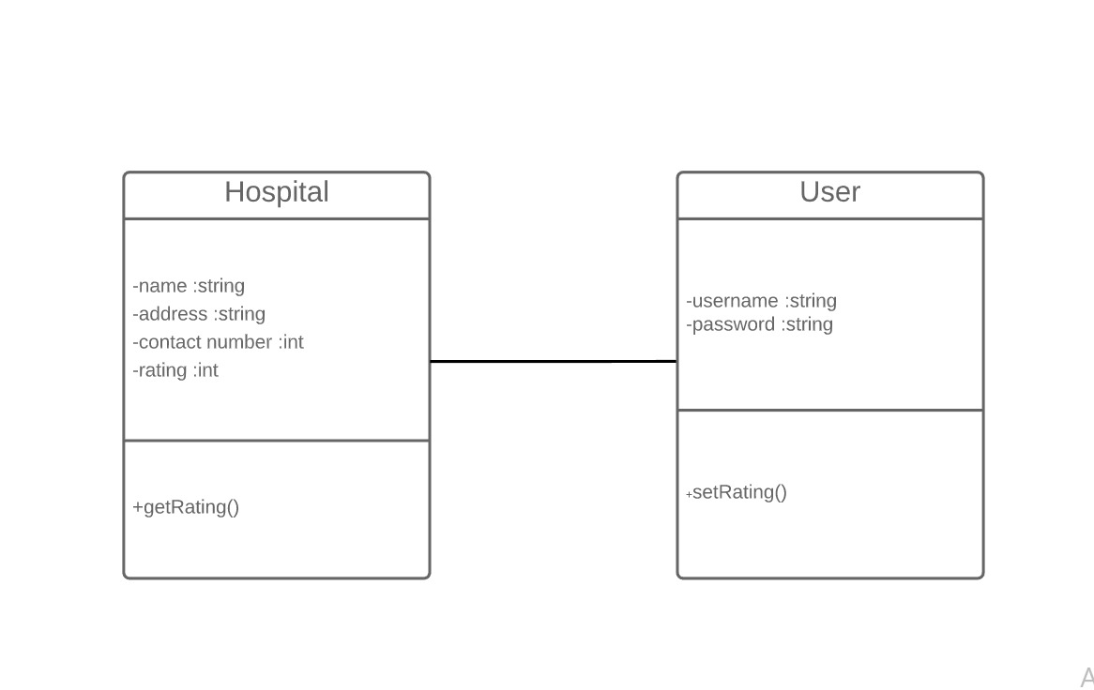

Figure 3.1.5 Rating Class Diagram

Table 3.1.4 Rating Class Diagram

|  |  |
| --- | --- |
| **Name** | User, Hospital |
| **Attributes** | name: name of the hospital address: address of the hospital contactinfo: contact information of the hospital rating: ratings given to the hospital |
| **Methods** | setRating: User rates the hospital according to their satisfactory levels. getRating: The hospital accesses the data regarding rating levels from the database. |
| **Relationship** | All the users can rate the hospital. |

**3.1.6 CD51V Online Consultancy Class Diagram**

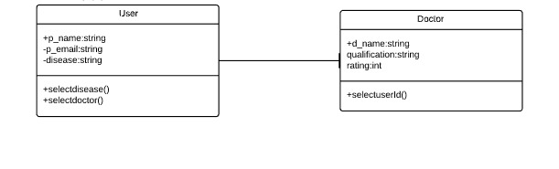

Figure 3.1. 6 Online Class Diagram

Table 3.1.5 Online Class Diagram

|  |  |
| --- | --- |
| **Name** | User, Doctor |
| **Attributes** | disease: name of the Disease d_name: name of the doctor qualification: qualification of the doctor rating: ratings given to a  doctor p_name:name of the user p_email:email of the user |
| **Methods** | selectDisease(): User has to select his problem selectDoctor():User has to select a doctor |
| **Relationship** | A user can select a doctor based on the rating and qualification. The relationship between the classes is association. |

**4.0 DETAILED DESIGN**

Detailed design is the phase where the design is refined and plans, specifications and estimates are created. It is the process of refining and expanding the preliminary design of a system or component to the extent that the design is sufficiently complete to begin implementation.

**4.1 GUI Design**

Graphical User Interface provides the user graphical means to interact with the system. GUI can be combination of both hardware and software. Using GUI, user interprets the software.

Initially, when the user opens the application, a splash screen is displayed for 3 seconds as shown in figure 4.1.1. After this, the user is directed to the login page where he/she is prompted to enter the username and password. After being authenticated, he is directed to the home page.

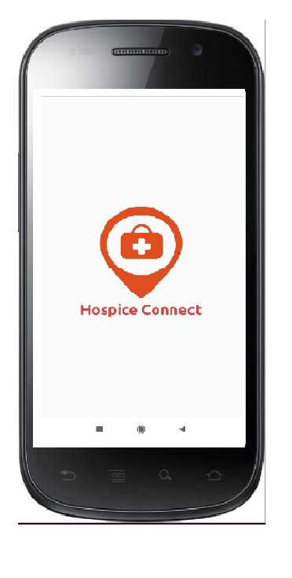 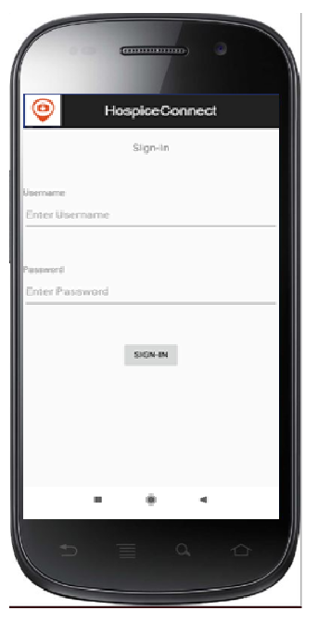 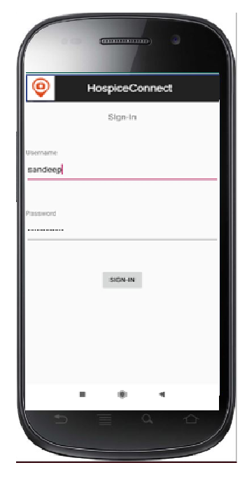

Figure 4.1.1 Hospice Connect GUI Design

**4.1.1 Search GUI Design**

User clicks on 'Locate Nearby Hospitals' which marks nearby hospitals on the map. Clicking on 'Emergency numbers' displays a list of emergency numbers.  
'Book an Appointment' provides the facility to book appointments. The search bar can be used to find specific hospitals Clicking a marker provides more details about the hospital as shown in figure 4.1.2.

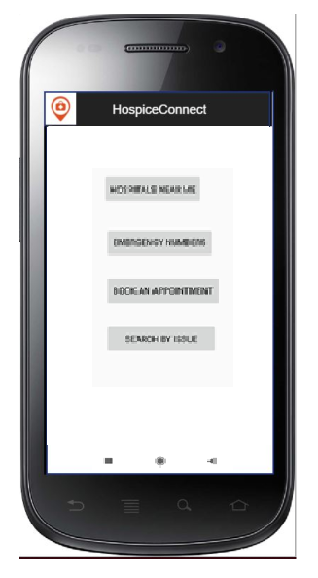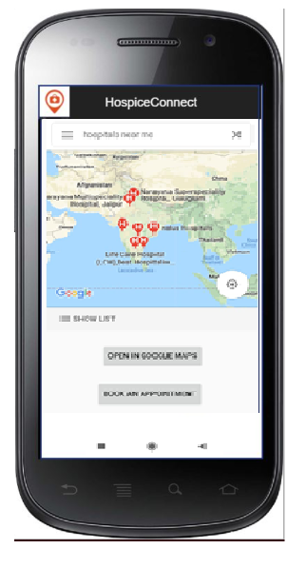

Figure 4.1.2 Search GUI Design

**4.1.2 Emergency GUI Design**

The User is expected to view the given list of ambulance service providers and choose a service to be contacted. He/She will then click on the call icon button present next to the given number to contact the chosen service provider as shown in figure 4.1.3.

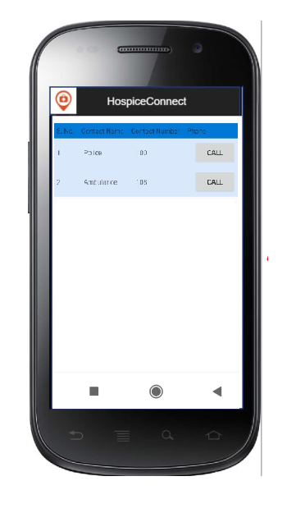

Figure 4.1.3 Emergency GUI Design

**4.1.3 Appointment GUI Design**

The user selects the Department, a list of available doctors in that particular department is displayed. After the doctor is selected, we can book a slot which is available. A page displays asking for personal details of the patient.  The user then clicks on the 'Book Now' button to make an appointment. A confirmation mail is sent to the respective email id. The user can then rate the app as shown in figure 4.1.4.  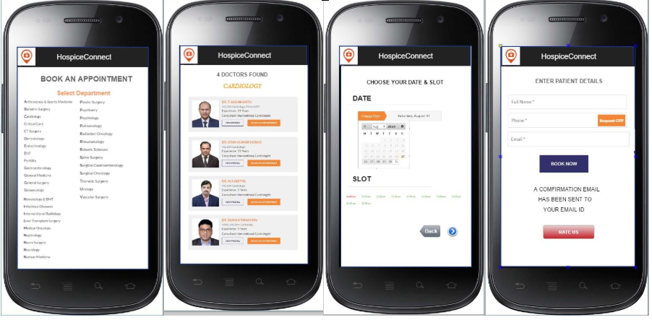

Figure 4.1.4 Appointment GUI Design

**4.1.4 Rating GUI Design**

The user has to click the "Rate Us" button so that the interface can display the rating page. After selecting any one of the displayed radio buttons, the user can then select a rating level. If the level is below average then the user is expected to fill the comment section as to how the services can be improved as shown in figure 4.1.5.

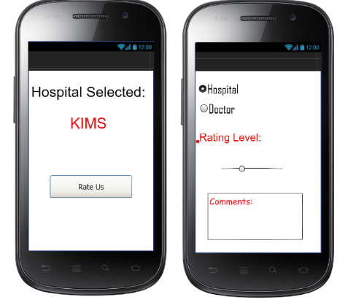

Figure 4.1.5 Rating GUI Design

**4.1.5 Online Consultancy GUI Design**

User clicks on the online consultancy button and then a list appears where he/she has to select his /her problem. Then the list of doctors will be displayed with their ratings, online status and other details. When the user selects the doctor a chat box opens up where the user can talk with the doctor after the chat is done, he/she should rate the doctor as shown in figure 4.1.6.

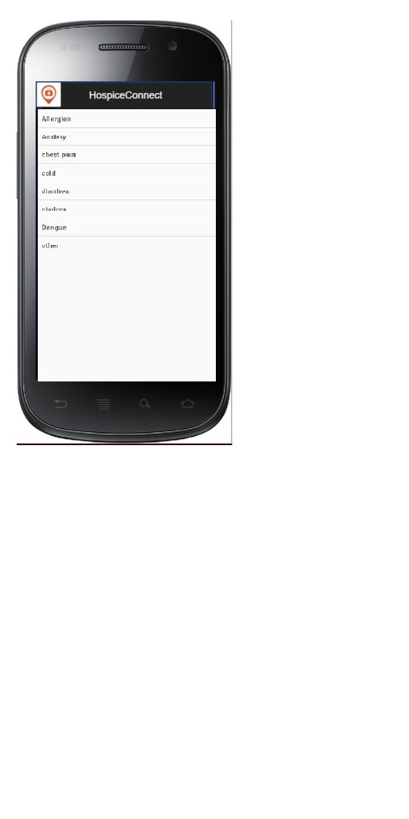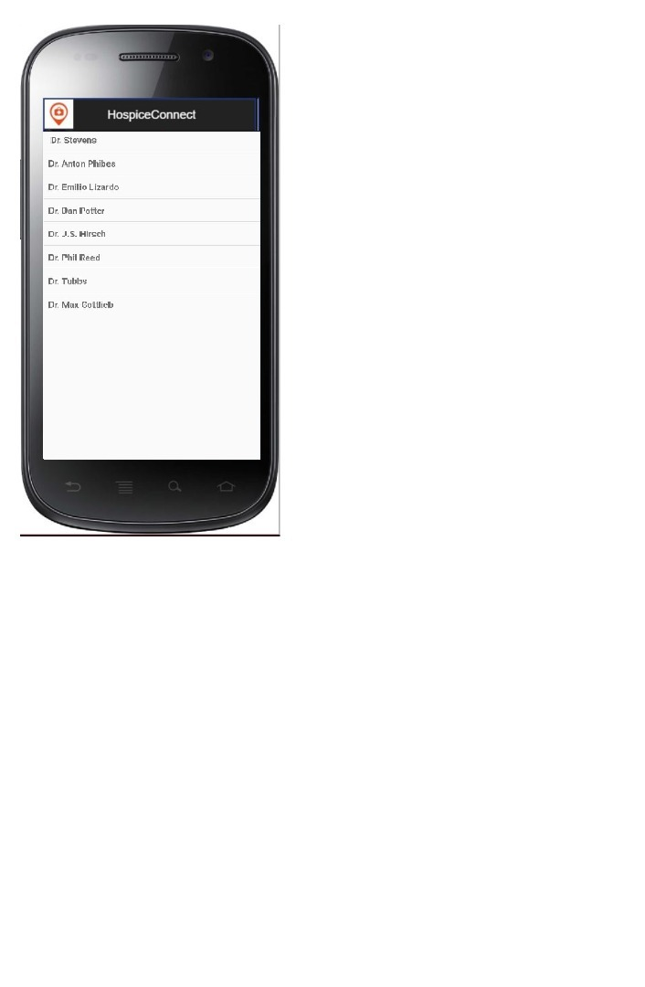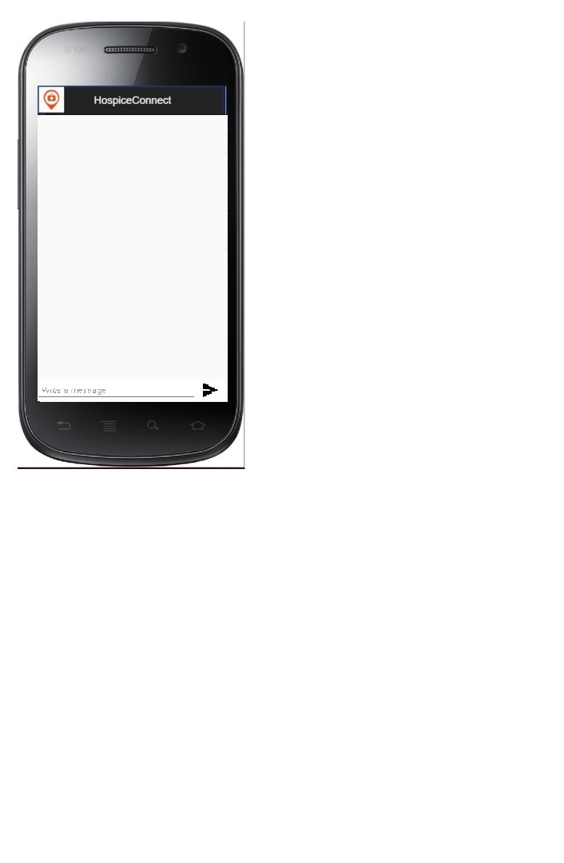

Figure 4.1.6 Online Consultancy GUI Design

**5.0 IMPLEMENTATION AND TESTING**

On receiving system design documents, the work is divided in modules/units and actual coding is started. Since, in this phase the code is produced so it is the main focus for the developer. This is the longest phase of the software development life cycle.

After the code is developed it is tested against the requirements to make sure that the product is actually solving the needs addressed and gathered during the requirements phase. During this phase all types of functional testing like unit testing, integration testing, system testing, acceptance testing is done as well as non-functional testing are also done.

**5.1 Test Case Design**

A test case is a set of conditions or variables under which a tester will determine whether a system under test satisfies requirements or works correctly. The process of developing test cases can also help find problems in the requirements or design of an application

**5.1.1 Search Test Case Design**

Table 5.1. 1 Search Test Case Design

|  |  |  |  |  |
| --- | --- | --- | --- | --- |
| **Name of Student:** | M. Sai Sandeep | | **Date Completed:** | 13 Oct 2019 |
| **Use Case ID#** | **Test Case ID#** | **Preconditions** | **Input** | **Expected output** |
| UC161 | TID1 | The user is authenticated, and is on the home screen. | The user clicks the "Hospitals near me" button. | A map with markers of hospitals near the user are displayed. |
| UC161 | TID2 | The user is authenticated, and is on the home screen. | The user clicks the "Hospitals near me" button, and then clicks on a marker. | A map with markers of hospitals near the user are displayed, along with details of the respective hospital. |
| UC161 | TID3 | The user is authenticated, and is on the home screen. | The user clicks the "Hospitals near me" button, and then clicks "Open in Google Maps". | Nearby hospitals are displayed in the Google Maps app. |
| UC161 | TID4 | The user is authenticated, and is on the home screen. | The user clicks the "Hospitals near me" button, and then clicks "Show List". | A list of nearby hospitals is displayed. |
| UC161 | TID5 | The user is authenticated, and is on the home screen. | The user clicks the "Hospitals near me" button, but there is no internet connection. | A grey screen is displayed instead of a map. |

**5.1.2 Emergency Test Case Design**

Table 5.1.2 Emergency Test Case Design

|  |  |  |  |  |
| --- | --- | --- | --- | --- |
| **Name of Student:** | Preeti Dcruze | | **Date Completed:** | 13th October 2019 |
| **Use Case ID#** | **Test Case ID#** | **Preconditions** | **Input** | **Expected output** |
| UC1C2 | TID1 | The user is required to enter the username and password required for the authentication | The user enters the username and password | The user is directed to the home screen |
| UC1C2 | TID2 | The user is authenticated.   He/she is on the home screen. | The user selects the 'Emergency Numbers' button. | The user is directed to the page that has a list of emergency numbers. |
| UC1C2 | TID3 | The user is authenticated.  He/She is on the home screen.  He/She then selects the 'Emergency Numbers' button. | The user selects the required service provider and clicks the call button adjacent to the number. | The Dialpad with the phone number of the selected service provider is displayed. |
| UC1C2 | TID4 | The user is authenticated.  He/She is on the home screen.  He/She selects the 'Emergency Numbers' button.  He/She then selects the emergency service provider from the list displayed | Then, the Dialpad with the phone number is displayed, the user clicks the call icon on the Dialpad. | The call is established with the selected service provider. |
| UC1C2 | TID5 | The user is authenticated.  He/She is on the home screen.  He/She selects the 'Emergency Numbers' button.  He/She then selects the emergency service provider from the list displayed.  He/She then clicks on the call button. | The user tries to call the service provider but doesn't have sufficient balance or is not in the required coverage area | He/She is intimated via a pre-recorded voice message. |

**5.1.3 Appointment Test Case Design**

Table 5.1.3 Appointment Test Case Design

|  |  |  |  |  |
| --- | --- | --- | --- | --- |
| **Name of Student:** | Prerna Patra | | **Date Completed:** | 13th October 2019 |
| **Use Case ID#** | **Test Case ID#** | **Preconditions** | **Input** | **Expected output** |
| UC1D3 | TID1 | The user has selected a hospital and the page to select a department is been displayed. | The user selects the department. | The user is directed to the page that has the list of doctors available in that department. |
| UC1D3 | TID2 | The department has been selected. | The user selects a doctor. | The user is directed to the page where he/she can choose a date and time to book an appointment. |
| UC1D3 | TID3 | The doctor has been selected. | The user chooses a date and slot. | The user is directed to the page where he/she can enter their personal details. |
| UC1D3 | TID4 | The date and time have been chosen. | The user enters the personal details and clicks on the 'BOOK NOW' button. | A confirmation email regarding successful booking of an appointment is sent to the respective email id of the user. |
| UC1D3 | TID5 | The date and time have been chosen. | The user enters the personal details but the entered email id is not valid. (Exception) Clicks on the 'BOOK NOW' button, but there is no internet connection. (Exception) | A pop up saying 'Invalid Email id' is displayed. A pop up saying 'No internet connection. Email cannot be sent' is displayed. |
| UC1D3 | TID6 | The personal details have been entered and the 'BOOK NOW' button has been clicked. | The user clicks on the 'RATE US' button. | The user is directed to the page where he/she can rate the hospital. |

**5.1.4 Rating Test Case Design**

Table 5.1.4 Rating Test Case Design

|  |  |  |  |  |
| --- | --- | --- | --- | --- |
| **Name of Student:** | Shreya Gandhe | | **Date Completed:** | 13 October 2019 |
| **Use Case ID#** | **Test Case ID#** | **Preconditions** | **Input** | **Expected output** |
| UC1H4 | TID1 | The user has logged in and utilized the services provided by the app. | The user selects the "rate us" button. | User is directed to a page which is a questionnaire regarding the quality of services provided by the hospital and doctors. |
| UC1H4 | TID2 | The user has logged in and utilized the services provided by the app. | The user rates the hospital with a single star. | A message pops up asking the user to enter the comment box with areas in need of improvement. |
| UC1H4 | TID3 | The user has logged in and utilized the services provided by the app. | The user rates the hospital with three stars. | A message pops up thanking the user and promises for a better service the next time. |
| UC1H4 | TID4 | The user has logged in and utilized the services provided by the app. | The user rates the hospital with five stars. | A message pops up thanking the user. |
| UC1H4 | TID5 | The user has logged in and utilized the services provided by the app. | The user has logged off without selecting the "rate us" button. | The next time the user opens the app he/she is asked to rate their previous experience first. |

**5.1.5 Online Consultancy Test Case Design**

Table 5.1.5 Online Consultancy Test Case Design

|  |  |  |  |  |
| --- | --- | --- | --- | --- |
| **Name of Student:** | **Yaganti Shreya** | | **Date Completed:** | 13 Oct 2019 |
| **Use Case ID#** | **Test Case ID#** | **Preconditions** | **Input** | **Expected output** |
| UC1V5 | TID1 | The User must be authenticated. He/she is on the Home page | The user selects the online consultancy button on the home page | The User is directed to a page where a list of diseases displayed and can select a disease from the list |
| UC1V5 | TID2 | The User must be authenticated. He/she is on the Home page and selects the online consultancy button. He /she is on the next page where a list of diseases is displayed. | The user selects a  disease from the list of diseases displayed. | The User is directed to a page where a list of doctors displayed and can select a doctor from the list |
| UC1V5 | TID3 | The User must be authenticated. He/she is on the Home page and selects the online consultancy button. He /she is on the next page where a list of diseases is displayed and selects a disease from the list. He /she is on the next page where a list of doctors is displayed. | The user selects a doctor based on the qualification. | The User is directed to a page where a chat box opens up and the user can chat with the doctor. |
| UC1V5 | TID4 | The User must be authenticated. He/she is on the Home page and selects the online consultancy button. He /she is on the next page where a list of diseases is displayed and selects a disease from the list. He /she is on the next page where a list of diseases is displayed and selects a disease from the list. He/she is on the page where the user can chat with the doctor. | The user chats with the doctor and ends the chat by clicking a chat button. | The user is directed to a page where he can rate the doctor. |
| UC1V5 | TID5 | The User must be authenticated. He/she is on the Home page and selects the online consultancy button. He /she is on the next page where a list of diseases is displayed and selects a disease from the list. He /she is on the next page where a list of doctors is displayed. | The User selects a doctor who is offline. | The user can see a popup message that says "The doctor is offline. please try later ". |

**5.2 Implementation**

The implementation phase is the process of converting a system specification into an executable system. If an incremental approach is used, it may also involve refinement of the software specification.

Initially, when the user opens the application, a splash screen is displayed for 3 seconds. After this, the user is directed to the login page where he/she is prompted to enter the username and password. After being authenticated, he is directed to the home page as shown in figure 5.2.1.

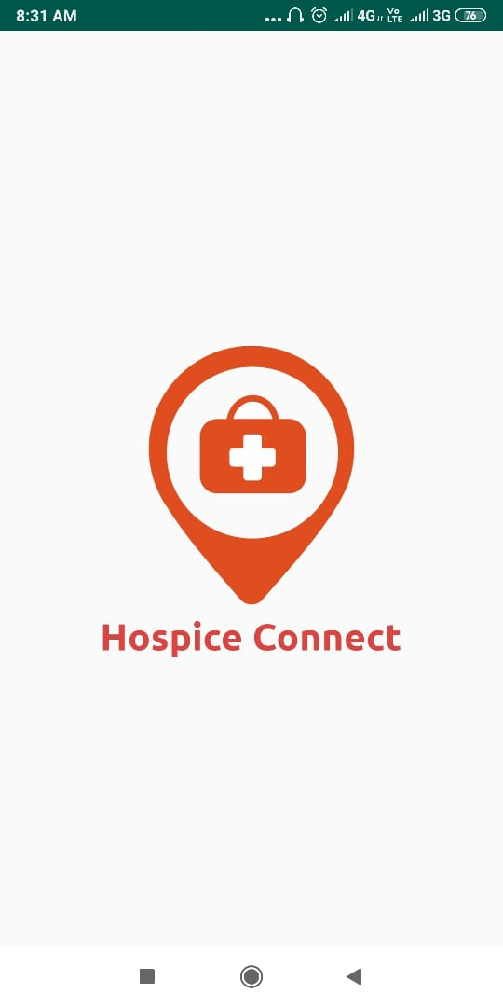 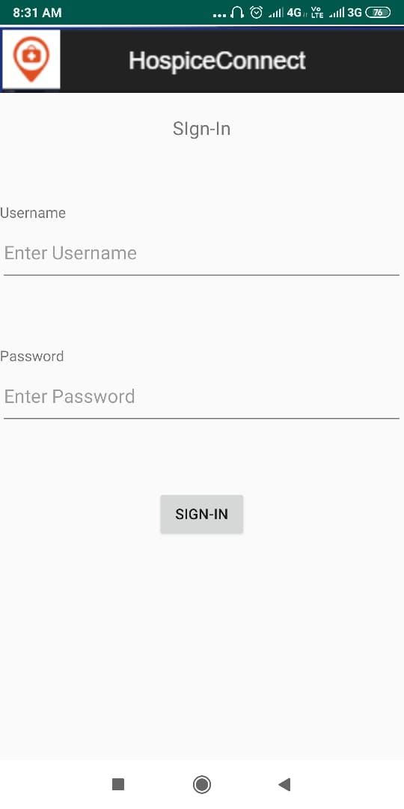 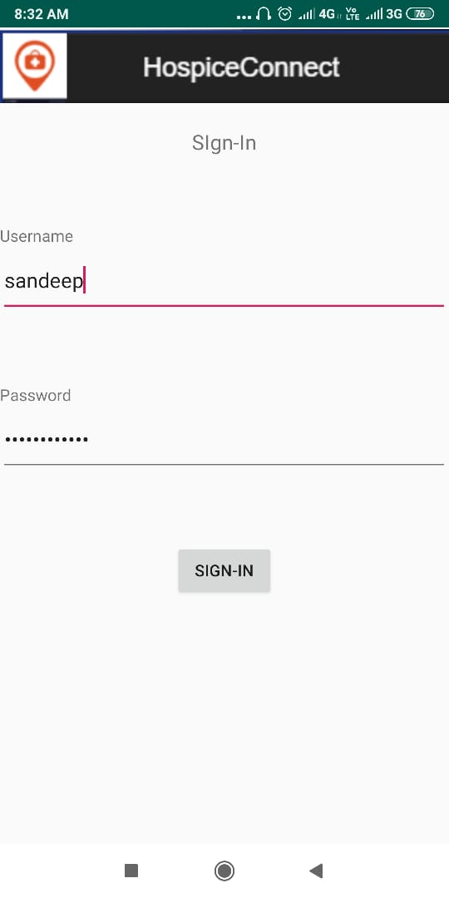

Figure 5.2.1 Hospice Connect Implementation

User clicks on 'Locate Nearby Hospitals' which marks nearby hospitals on the map. Clicking on 'Emergency numbers' displays a list of emergency numbers. 'Book an Appointment' provides the facility to book appointments. The search bar can be used to find specific hospitals. If the user wants to return to the main menu, he/she can do so by clicking on the back button in the navigation bar as shown in figure 5.2.2.

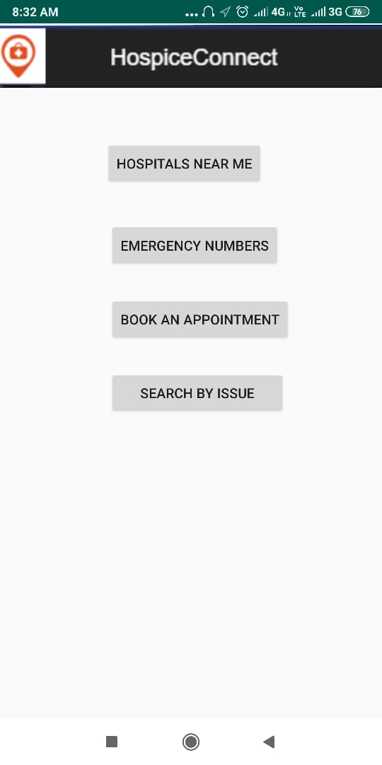 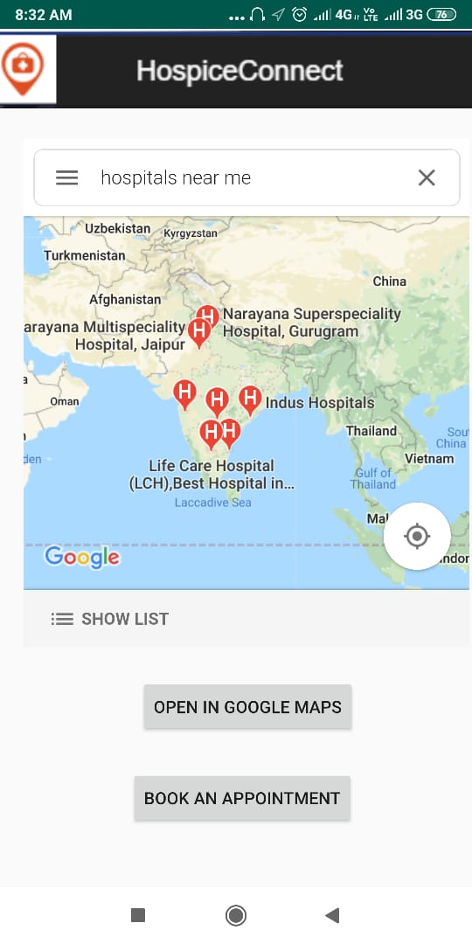

Figure 5.2.2 Search Implementation

In case of an emergency, the user can also book an ambulance by viewing the given list of ambulance service providers and choose a service to be contacted. He/She can then click on the call icon button present next to the given number to contact the chosen service provider. An alert is displayed on the screen which asks for confirmation from the user about the service provider he/she has chosen as shown in figure 5.2.3.

 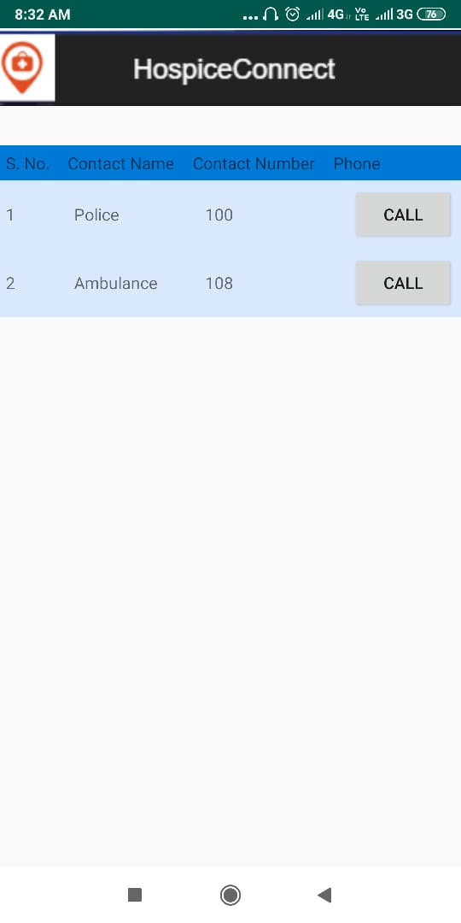

Figure 5.2.3 Emergency Implementation

The user can book an appointment by selecting the Department, a list of available doctors in that particular department is displayed. After the doctor is selected, we can book a slot which is available. A page displays asking for personal details of the patient. The user then clicks on the 'Book Now' button to make an appointment. A confirmation mail is sent to the respective email id. The user can then rate the app as shown in figure 5.2.4 and 5.2.5.

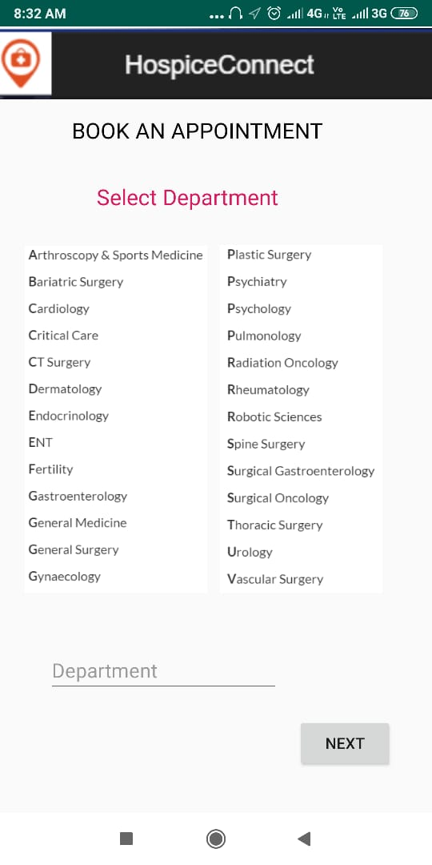 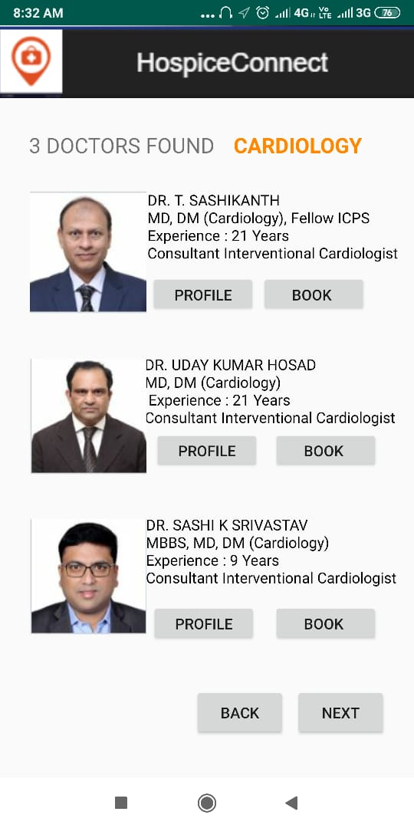

Figure 5.2.4 Appointment Implementation

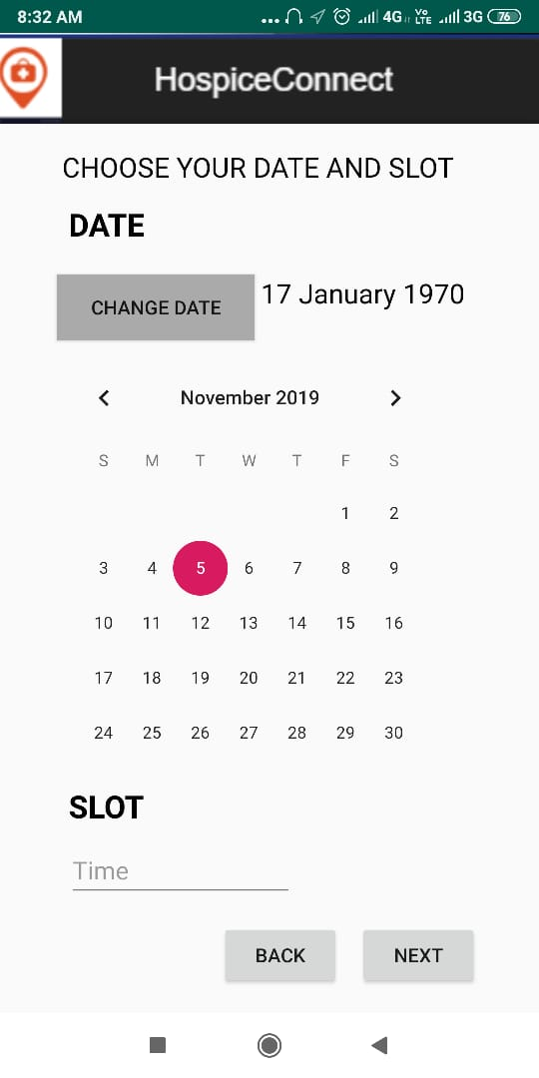 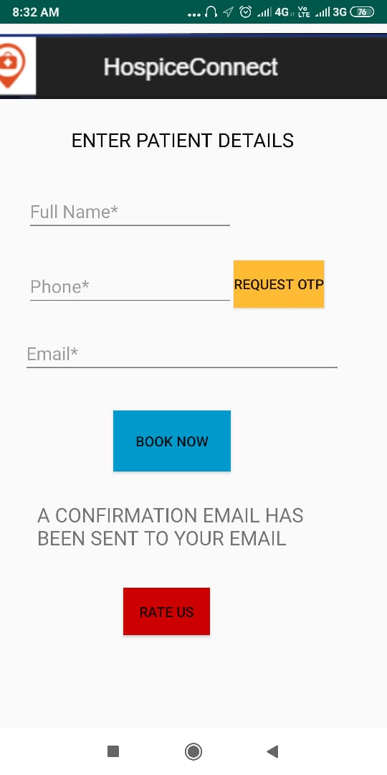

Figure 5.2.5 Appointment Implementation

The user has to click the "Rate Us" button so that the interface can display the rating page. After selecting any one of the displayed radio buttons, the user can then select a rating level. If the level is below average then the user is expected to fill the comment section as to how the services can be improved.

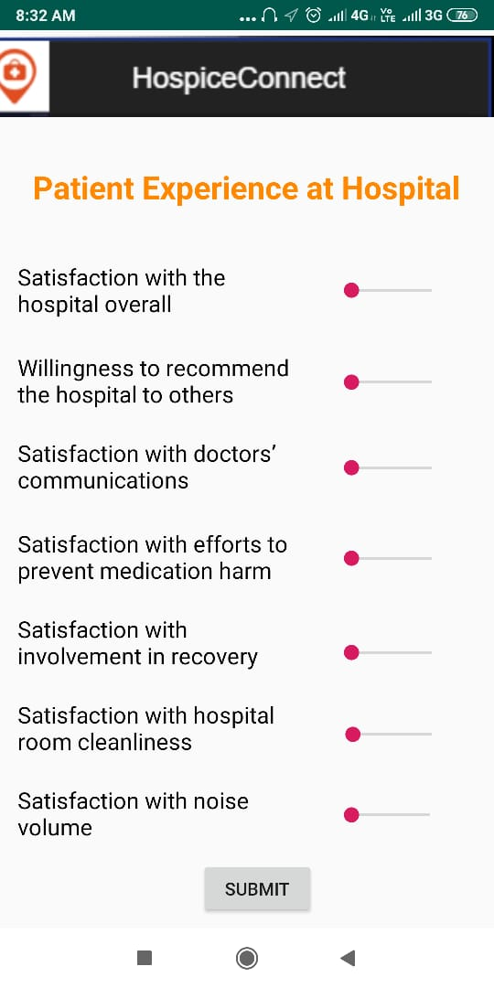

Figure 5.2.6 Rating Implementation

User clicks on the online consultancy button and then a list appears where he/she has to select his /her problem. Then the list of doctors will be displayed with their ratings, online status and other details. When the user selects the doctor a chat box opens up where the user can talk with the doctor after the chat is done, he/she should rate the doctor.

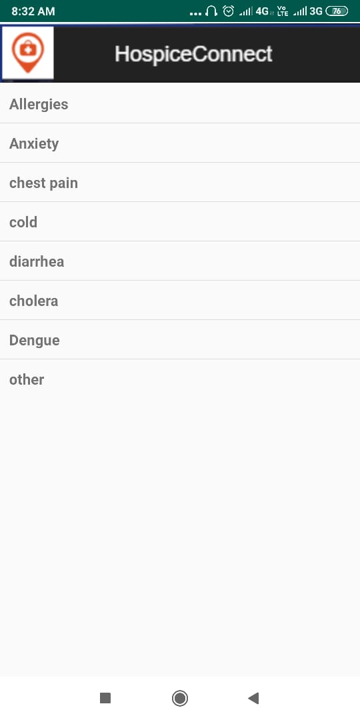 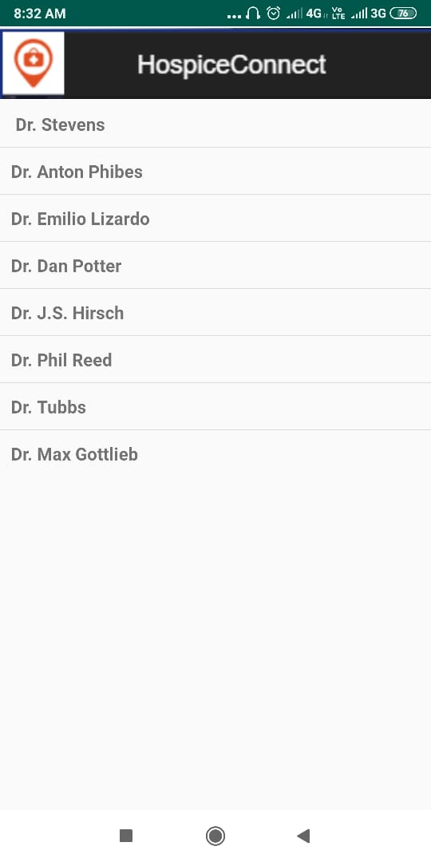 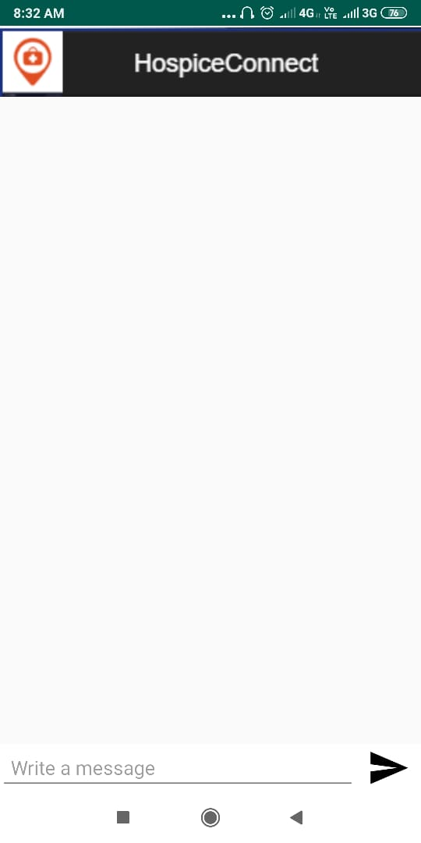

Figure 5.2.7 Online Consultancy Implementation

**6.0 CONCLUSION AND FUTURE WORK**

**Appendix A: Requirement Traceability**

Performing a requirements traceability analysis is an important part of the software engineering process as it ensures that all of the requirements have been adequately considered during each phase of the project, and that there aren't any scope 'holes' in the developed system due to missed requirements. The activity also ensures that all of the requirements are internally consistent with each other and support the overarching business drivers, goals and objectives.

Table 6.1: Requirements Traceability Matrix

|  |  |  |  |  |  |  |  |
| --- | --- | --- | --- | --- | --- | --- | --- |
| **User Requirement IDs** | | KYH01 | KYH01 | KYH02 | KYH03 | KYH04 | KYH05 |
| **User Requirement**  **Description** | | User Validation | Search for hospitals | Emergency Service Provider | Booking Appointment | Rate Doctors and Hospitals | Online Consultancy |
| UC161 | Search for hospitals | Yes | Yes |  |  |  |  |
| UC1C2 | Emergency Service Provider | Yes |  | Yes |  |  |  |
| UC1D3 | Booking Appointment | Yes | Yes |  | Yes |  |  |
| UC1H4 | Rate Doctors and Hospitals | Yes |  |  | Yes | Yes |  |
| UC1V5 | Online Consultancy | Yes |  |  |  |  | Yes |

### Appendix B: Design Traceability

Design traceability--documenting the relationships between layers of design--can help systems engineers better manage requirements changes in their projects. Using traceability, engineers can identify immediate impact; calculate, prune, and elaborate the impact tree; and design and apply change.

Table 6.2: Design Traceability Matrix

|  |  |  |  |  |  |  |
| --- | --- | --- | --- | --- | --- | --- |
| **CRC IDs** | | CD001 | CD002 | CD516 | CD51C | CD51V |
| **Class Name** | | Hospital | User | Map | Emergency List | Doctor |
| UC161 | Search for hospitals | Yes |  | Yes |  |  |
| UC1C2 | Emergency Service Provider |  |  |  | Yes |  |
| UC1D3 | Booking Appointment | Yes | Yes |  |  |  |
| UC1H4 | Rate Doctors and Hospitals | Yes | Yes |  |  |  |
| UC1V5 | Online Consultancy |  | Yes |  |  | Yes |

### Appendix C: Data Dictionary

Hospice: an institution providing medical and surgical treatment and nursing care for sick or injured people.

Online Consultancy: using the Internet to ask a group of people their opinion on one or more specific topics, allowing for trade-offs between participants.

### Appendix D: Test Log

Table 6.1.1 Search Test Log

|  |  |  |  |  |  |  |  |
| --- | --- | --- | --- | --- | --- | --- | --- |
| **Name of Student:** | M. Sai Sandeep | | | **Date of Testing:** | | 15th November 2019 | |
| **Use Case ID#** | **Test Case ID#** | **Preconditions** | **Input** | **Expected output** | **Actual Output** | | **Pass/**  **Fail** |
| UC161 | TID1 | The user is authenticated, and is on the home screen. | The user clicks the "Hospitals near me" button. | A map with markers of hospitals near the user are displayed. | A map with markers of hospitals near the user are displayed. | | Pass |
| UC161 | TID2 | The user is authenticated, and is on the home screen. | The user clicks the "Hospitals near me" button, and then clicks on a marker. | A map with markers of hospitals near the user are displayed, along with details of the respective hospital. | A map with markers of hospitals near the user are displayed, along with details of the respective hospital. | | Pass |
| UC161 | TID3 | The user is authenticated, and is on the home screen. | The user clicks the "Hospitals near me" button, and then clicks "Open in Google Maps". | Nearby hospitals are displayed in the Google Maps app. | Nearby hospitals are displayed in the Google Maps app | | Pass |

Table 6.1.2 Emergency Test Log

|  |  |  |  |  |  |  |  |
| --- | --- | --- | --- | --- | --- | --- | --- |
| **Name of Student:** | Preeti Dcruze | | | **Date of Testing:** | | 15th November 2019 | |
| **Use Case ID#** | **Test Case ID#** | **Preconditions** | **Input** | **Expected output** | **Actual Output** | | **Pass/**  **Fail** |
| UC1C2 | TID2 | The user is authenticated. He/she is on the home screen. | The user selects the 'Emergency Numbers' button. | The user is directed to the page that has a list of emergency numbers. | The user is directed to the page that has a list of emergency numbers. | | Pass |
| UC1C2 | TID3 | The user is authenticated. He/She is on the home screen. He/She then selects the 'Emergency Numbers' button. | The user selects the required service provider and clicks the call button adjacent to the number. | The Dialpad with the phone number of the selected service provider is displayed. | The Dialpad with the phone number of the selected service provider is displayed. | | Pass |
| UC1C2 | TID4 | He/She selects the 'Emergency Numbers' button. He/She then selects the emergency service provider from the list displayed | Then, the Dialpad with the phone number is displayed, the user clicks the call icon on the Dialpad. | The call is established with the selected service provider. | The call is established with the selected service provider. | | Pass |

Table 6.1.3 Appointment Test Log

|  |  |  |  |  |  |  |  |
| --- | --- | --- | --- | --- | --- | --- | --- |
| **Name of Student:** | Prerna Patra | | | **Date of Testing:** | | 15th November 2019 | |
| **Use Case ID#** | **Test Case ID#** | **Preconditions** | **Input** | **Expected output** | **Actual Output** | | **Pass/**  **Fail** |
| UC1D3 | TID2 | The department has been selected. | The user selects a doctor. | The user is directed to the page where he/she can choose a date and time to book an appointment. | The user is directed to the page where he/she can choose a date and time to book an appointment. | | Pass |
| UC1D3 | TID3 | The doctor has been selected. | The user chooses a date and slot. | The user is directed to the page where he/she can enter their personal details. | The user is directed to the page where he/she can enter their personal details. | | Pass |
| UC1D3 | TID4 | The date and time have been chosen. | The user enters the personal details and clicks on the 'BOOK NOW' button. | A confirmation email regarding successful booking of an appointment is sent to the respective email id of the user. | A confirmation email regarding successful booking of an appointment is sent to the respective email id of the user. | | Pass |

Table 6.1.4 Rating Test Log

|  |  |  |  |  |  |  |  |
| --- | --- | --- | --- | --- | --- | --- | --- |
| **Name of Student:** | Shreya Gandhe | | | **Date of Testing:** | | 15th November 2019 | |
| **Use Case ID#** | **Test Case ID#** | **Preconditions** | **Input** | **Expected output** | **Actual Output** | | **Pass/**  **Fail** |
| UC1H4 | TID1 | The user has logged in and utilized the services provided by the app. | The user selects the "rate us" button. | User is directed to a page which is a questionnaire regarding the quality of services provided by the hospital and doctors. | User is directed to a page which is a questionnaire regarding the quality of services provided by the hospital and doctors. | | Pass |
| UC1H4 | TID2 | The user has logged in and utilized the services provided by the app. | The user rates the hospital with a single star. | A message pops up asking the user to enter the comment box with areas in need of improvement. | A message pops up asking the user to enter the comment box with areas in need of improvement. | | Pass |
| UC1H4 | TID3 | The user has logged in and utilized the services provided by the app. | The user rates the hospital with three stars. | A message pops up thanking the user and promises for a better service the next time. | A message pops up thanking the user and promises for a better service the next time. | | Pass |

Table 6.1.5 Online Consultancy Test Log

|  |  |  |  |  |  |  |  |
| --- | --- | --- | --- | --- | --- | --- | --- |
| **Name of Student:** | Yaganti Shreya | | | **Date of Testing:** | | 15th November 2019 | |
| **Use Case ID#** | **Test Case ID#** | **Preconditions** | **Input** | **Expected output** | **Actual Output** | | **Pass/**  **Fail** |
| UC1V5 | TID1 | The User must be authenticated He/she is on the Home page | The user selects the online consultancy button on the home page | The User is directed to a page where a list of diseases displayed and can select a disease from the list | The User is directed to a page where a list of diseases displayed and can select a disease from the list | | Pass |
| UC1V5 | TID2 | The User selects the online consultancy button. He /she is on the next page where a list of diseases is displayed. | The user selects a  disease from the list of diseases displayed. | The User is directed to a page where a list of doctors displayed and can select a doctor from the list | The User is directed to a page where a list of doctors displayed and can select a doctor from the list | | Pass |
| UC1V5 | TID3 | The User selects a disease from the list. He /she is on the next page where a list of doctors is displayed. | The user selects a doctor based on the qualification. | The User is directed to a page where a chat box opens up and the user can chat with the doctor. | The User is directed to a page where a chat box opens up and the user can chat with the doctor. | | Pass |